1. Scatter plot (e.g., section 3.2.2)

ggplot(data = iris) + geom_point(mapping = aes(x = Sepal.Length, y = Petal.Length))



1. Colored scatter Plot (e.g., plot 3 in section 3.3)

ggplot (data = iris, mapping = aes(x = Sepal.Length, y = Petal.Length, colour = Species)) + geom_point() + gemo_line()



ggplot (data = iris, mapping = aes(x = Sepal.Length, y = Petal.Length, colour = Species)) + geom_point()



1. Smoothed line plot (e.g., section 3.6)

ggplot(data = iris) + grom-smooth(mapping = aes(x = Sapel.Length + y = Petal.Length, linrtype = Species))





1. Bar chart (e.g., section 3.7)

ggplot(data = iris) +

+ geom_bar(mapping = aes(x = Sepal.Length))

ggplot(data = iris) +

+ geom_bar(mapping = aes(x = Petal.Length))





1. Box plot (e.g., section 3.9)

ggplot(data = iris, mapping = aes(x = Sepal.Length, y = Petal.Length)) +

+ geom_boxplot()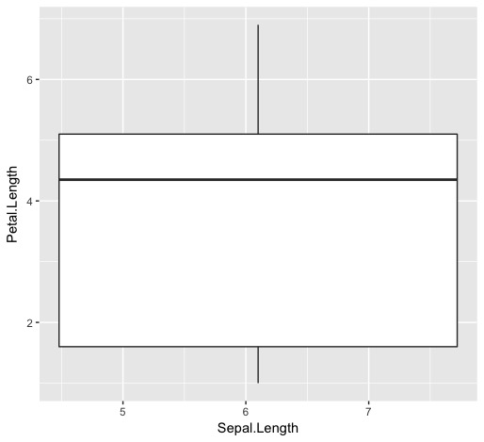

ggplot(data = iris, mapping = aes(x = Sepal.Length, y = Petal.Length)) +

+ geom_boxplot() + geom_boxplot() +

+ coord_flip()